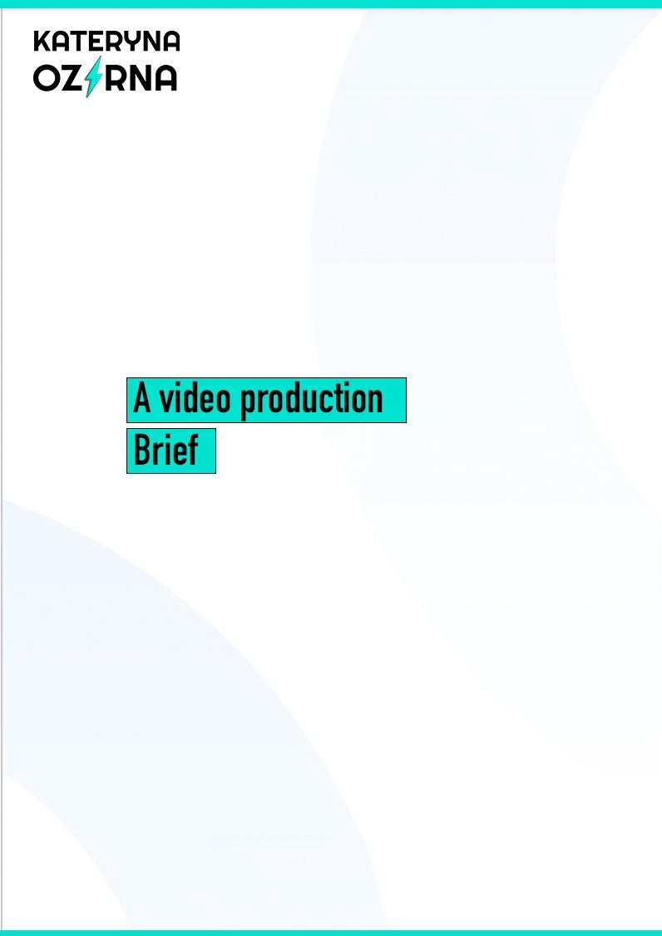

Content
1. General questions
2. Technical requirements
3. Availability of source materials
4. What is needed in addition
5. Specific questions
6. Milestones and Timeline

Customer: | Forename and Surname
Filling date:
Due Date:
Phone:
E-mail:
Social media:
Website (if you have it):

GENERAL QUESTIONS
(are needed to develop a video concept)
- What are you trying to communicate?
I want this video for:
◌ For sale of goods or services (presentation)
◌ For sale of a personal brand (self-presentation)
◌ For information about promotions, discounts and events (promotion)
◌ For congratulations on the holiday
◌ Other:
Description of the video:
- What is the reaction you are expecting from the viewer?
If not one - specify the order of preferences
◌ Evoke emotions
◌ Serious
◌ Humoristic
◌ Brand image creation
◌ Other:
Description:
- Which action are you incentivizing?
e.x. Call to action to buy a product
- What should be put aside in the viewer's head in the end:
◌ Specific information contained in the video
◌ The main ideas of the video
◌ Just a good emotional impression of the video for brand image building
◌ To become a part of the brand
◌ Other:
Description
- What associations should arise when watching the video:
Description
- The specifics of the target audience for which the video is designed:
◌ Corporate client
◌ Wholesale customer/dealer
◌ Retail customer
◌ Potential customer
◌ Employees of the company
◌ Subscriber audience
◌ Other:
Description
- The presence of similar products/services from competitors/partners (if applicable):
◌ Yes
◌ No
◌ It's not known.
If yes, please share the links to their videos:
- Benefits of your product and/or services (if applicable)
A few basic advantages and advantages
- Links to examples of videos you like:
http://...
- Links to examples of videos you DON't like:
http://...
TECHNICAL REQUIREMENTS
Technical requirements for the video
Video format | E.g. MP4
Duration | E.g. 2 minutes 30 seconds
Type | Vertical/Horizontal
Sound | Share the link to the example of a soundtrack you would like to have in the video
Text | Yes/No
Resolution | E.g. 1920x1080
Aspect Ratio | E.g. 3:2
AVAILABILITY OF AUXILIARY MATERIALS
◌ Photos: Yes/No (If yes, please attach to the letter back or send it in any convenient way)
◌ Video materials (indicate the format): Yes/No (If yes, please attach to the letter back or send it in any convenient way)
◌ Text (ready for the video): Yes/No (If yes, please attach to the letter back or send it in any convenient way)
◌ Brand-book (Logo, slogan, corporate colors, etc.): Yes/No (If yes, please attach to the letter back or send it in any convenient way)
◌ Scenario: Yes/No (If yes, please attach to the letter back or send it in any convenient way)
List
WHAT YOU NEED IN ADDITION
◌ Speaker's voiceover
◌ Male voice
◌ Women's Voice
◌ Scenario
◌ Photo-shooting
◌ other
Specify
SPECIFIC QUESTIONS:
1. Video usage (e.x. for digital use on a website/ecommerce/social media/paid ads):
Specify
2. The colors & patterns (what colors would you like to see in this video):
Specify
3. Angles you would like the video to be shot with (e.x. straight-on, 45°, 75°, 90° flat lay)
Specify
4. Prop suggestions (if applicable):
Specify
5. What to avoid:
Specify
6. Additional comments:
Specify

MILESTONES:
- Share script with shot ideas (a storyboard);
- Share the first draft of the edited video;
- Share the second draft of the edited video;
- Deliver the final version of the video.

